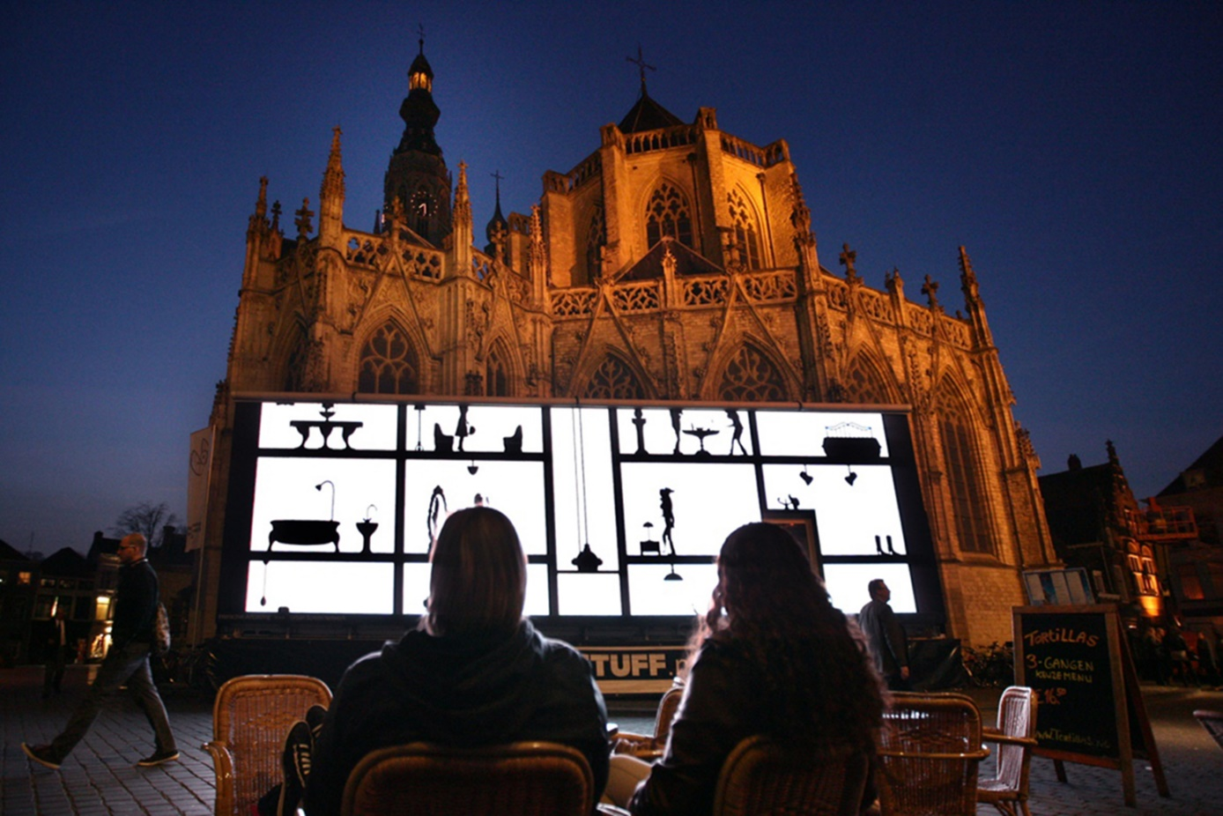
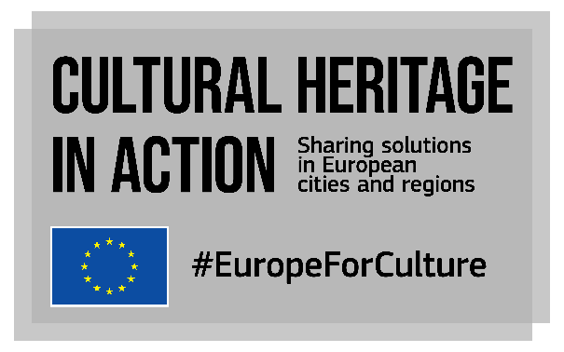
CALL FOR HOSTS for onsite PEER LEARNING VISITS
Closing date: 31 December 2021

What is ‘Cultural Heritage in Action’?
Cultural Heritage in Action is one of the actions of the European Framework for Action on Cultural Heritage of the European Commission. Started in 2020, it is a peer-learning programme that already allowed over 100 local and regional policy makers to exchange knowledge on cultural heritage, with a focus on participatory governance, adaptive reuse of heritage buildings and quality of interventions.
In its second phase (2021-2023), the project will continue to empower cities and regions to strengthen their cultural heritage policies and initiatives as well as develop innovative solutions to preserve cultural heritage assets.
Our consortium led by Eurocities with KEA, ERRIN, Europa Nostra and Architects’ Council of Europe leads the project funded by the European Union’s Creative Europe programme until January 2023.

What will happen in until January 2023?
We have produced a catalogue of 32 good practices from EU cities, regions, urban, non-urban and rural areas, organised 10 online peer-learning visits bringing together 20+ participants per visit and produced 39 videos presenting practices from online host cities and regions.
Until January 2023, we will enrich our catalogue with 30 more good practices from EU cities, regions, urban, non-urban and rural areas and organise a set of peer-learning activities, including 5 onsite peer learning visits. We are confident we can organise onsite visits now, paying attention to the sanitary regulations in place and keeping an eye on the sanitary situation throughout Europe.
We are now organising peer learning activities for European cities and regions.
What are peer learning activities? Peer-learning activities provide opportunities for participants, experts, decision makers and stakeholders to learn more about a specific city/region or practice and share knowledge about similar initiatives or experiences.
Cultural Heritage in Action peer learning activities will take place between November 2021 and December 2022 and will be organised by our project team, cities/regions and dedicated experts. Activities can take different formats, happen online and onsite, and will be adapted to the wishes and needs of the city/region applying, but also to the relevance of the practices shared.
What are peer-learning visits?
Peer-learning visits are part of the catalogue of peer learning activities offered by Cultural Heritage in Action and will take place onsite.
Visits are an opportunity for experts, decision makers and stakeholders to visit another city/region and see first-hand how it has successfully implemented policies and projects. Visits will be organised by host cities/regions in cooperation with members of the consortium implementing Cultural Heritage in Action. About 25 participants, who will be selected through calls for interest in 2022, will be able to attend each visit. Cultural Heritage in Action’s peer learning visits will take place between February and November 2022 and will be organised by the project, hosts cities/regions and dedicated experts.
To continue the peer-learning experience after the visit, a number of online activities will be organised with the hosts, participants and dedicated experts:
- An online deep diving session: online follow-up workshop to replicate local example(s), one month after the onsite visit. Short (max. 2.5h), open to the group of selected participants and external stakeholders (and potentially to other interested participants) with the involvement of experts who attended the onsite visit. The objective is to come back to one specific practice presented during the onsite visit and discuss more in depth its transferability aspects. Participants come back on the lessons learnt from the visit and expose them to external participants.
- An online monitoring session: a 1-hour workshop to follow up on transferability and replication of practices in the participants’ cities/ regions. Open to the same group of participants who took part in the onsite visit, moderated by experts. The session is based on participants’ feedback report and follows up on their implementation plans after their visit to the host city/region.
I want to host a visit, is this call for me?
This call is open to local and regional administrations of all sizes (rural areas, medium size cities, large and capital cities, regions) from the 27 European Union countries as well as the UK. In some cases, the questionnaire can be filled in “on behalf of” a local/regional administration, for example by a university, an architect or a local/regional stakeholder; a written endorsement by a representative of the local/regional administration at the origin of the practice should then be provided.
If you have any doubt, please contact us at culturalheritageinaction@eurocities.eu .

Why should I be a candidate for hosting an onsite visit?
You will have an exclusive opportunity to be one of the 5 cities or regions to host an in-person peer-learning visit. Previous hosts have found this experience extremely beneficial and valued it as a vehicle to bolster their international reputation, create lasting ties with other cities, and get fresh ideas and feedback.
Hosting a visit is just as beneficial as joining a visit! Hosting allows to benefit from the experience of visitors and from their feedback; to gain a reputation for being an international frontrunner; to foster work with your local partners.

What is the format of a peer-learning visit?
Each visit will last 3 days and 2 nights and will combine meetings with local policy makers and stakeholders, site visits and solution-building workshops. The working language will be English.

What does hosting a visit mean for my city/region? What will I be expected to do?
The host city/region will:
- Appoint a local contact person
- Liaise with the consortium to agree on the objectives and format of the visit
- Develop an agenda for the whole duration of the visit, in cooperation with our consortium
- Provide documentation on the practices implemented locally
- Participate in follow up online activities with the same group of participants or with a larger group of interested stakeholders

What are the costs for my city/region?
Costs are basically human resources from your city/region that are necessary to prepare the visit, and meeting rooms. The project will cover travel and accommodation costs for visitors, as well as lunches and dinners (our consortium will take care of all logistical aspects).

How will the 5 hosts be selected?
Our consortium’s team of experts will use the criteria below to assess responses to this call. A list will then be proposed to the European Commission for final decision.
- Quality and clarity of the response to the call
- Clear focus defined for the visit
- Transferability of presented practices from the host to the visitors
- Availability of decision makers (in charge of culture and other areas such as economic development, urban regeneration, innovation) during the visit
- Ability to involve local stakeholders and organisations (outside city/regional staff)
- Demonstrated experience in hosting similar visits
- Thematic balance between the 3 topics of the project and geographical balance
- Geographical and demographic spread among the 5 hosts: hosts will be as representative as possible of Europe’s diversity: geographical spread, and spatial areas (small/medium/large city, region, rural area)
- International accessibility: flight and rail/road connections

Which themes should the visit relate to?
We consider cultural heritage as “resources inherited from the past in all forms and aspects – tangible, intangible and digital (born digital and digitized), including monuments, sites, landscapes, skills, practices, knowledge and expressions of human creativity, as well as collections conserved and managed by public and private bodies such as museums, libraries and archives” (Council conclusions on cultural heritage as a strategic resource for a sustainable Europe, May 2014).
We are looking for host cities and regions presented practices linked to at least 1 of the 3 topics described below:

Recovery and resilience through cultural heritage in a post pandemic world
Key words: COVID19, resilience, long-term recovery, health & wellbeing
Entering a post pandemic world, the cultural heritage sector has an opportunity and an important role to play in building back cities and regions better. Cultural heritage is a key component in the recovery process due to its potential to engage with contemporary events and co-produce new knowledge and heritage narratives with more diverse communities and perspectives. The cultural heritage capacity to increase citizens engagement would benefit cultural institutions in a post-Covid world where the trend is to localise the audience. The sanitary crisis is an opportunity to strengthen management strategies based on prevention and disaster response. COVID-19 has proved our creativity to deliver new cultural offers and services that will now become the new normal in our leisure time. Our public heritage spaces are now exposed to new uses accessible to all and available to meet outdoors (from concerts to street performances).
Key questions your good practice might respond to:
- What have cities/regions learnt from the pandemic crisis when it comes to cultural heritage management/governance etc.? Are they now better equipped to deal with future crisis? How to keep the communities involved in the delivery of new cultural offers and services linked to cultural heritage?
- What has been the impact of the pandemic crisis on the uses of cultural heritage buildings and public spaces? How have they been reinvented for new uses? How to make sure they remain accessible to all and vector of health, wellbeing and quality of life in cities and regions?
- How will cities and regions use the recovery and resilience facility (national plans) in the future? What should be the role of European funding for recovery and building back better?
- How are digital tools and opportunities integrated in the development and management of cultural heritage projects and initiatives?

Cultural heritage for local sustainable development
Key words: Sustainability, sustainable tourism, climate change, European Green Deal, resilience, urban regeneration, adaptive re-use of heritage buildings, quality of interventions on cultural heritage
The effects of climate change are already degrading and irreversibly changing our natural and cultural heritage. It puts thousands of sites with cultural, historic, and archaeological values at risk of being damaged or lost altogether, including archaeological sites that have not yet been discovered. Structural changes are necessary in the management of our cultural environment. In that sense, the climate crisis also offers a moment of radical new thinking and innovation and an opportunity to explore and test innovative ways to protect and adapt monuments, historical buildings and sites from the effects of climate change and natural hazards. Bringing environmental sustainability and action on climate change into their work. Doing so will unlock the potential of cultural heritage to be a driver for a new green and sustainable economy; enhance economic, social, and cultural value in cities and regions; and contribute to all key areas of the European Green Deal.
Key questions your good practice might respond to:
- How are cities and regions making the most of cultural heritage to face future changes in the climate and adapt their local territories to these new threats? How are cities and regions protecting cultural heritage from risks linked to climate change?
- How to ensure a sustainable urban and regional regeneration through cultural heritage? How to develop a more sustainable cultural tourism in cities and regions?
- How can cities and regions invest in cultural heritage to ensure a successful European Green Deal? How are cities and regions contributing through cultural heritage investments to the New European Bauhaus? How is cultural heritage contributing to reaching the Sustainable Development Goals at local level?

Governance and financing: new roles for local and regional authorities
Key words: Support to cultural heritage, funding, partnerships, empowerment, participatory governance, citizen participation
Local and regional authorities are increasingly aware of the importance to place citizens as actors rather than users of their territory. Over the years, citizens have been encouraged to take on a wider range of responsibilities to ensure that local services continue to be delivered and improved effectively in the future. Culture and cultural heritage have often been at the forefront of citizens participation and engagement, as artistic intervention is a good trigger to have citizens interested and willing to shape their environment in a co-designed manner. Investing in culture and local cultural heritage can create opportunities to engage and empower citizens through a strong participatory approach. Besides, culture and cultural heritage have often been used as tools to test and renew local governance models into something more flexible, dialogue-based and co-designed, be it with local stakeholders, associations and organisations, and even inside local and regional authorities themselves.
Key questions your good practice might respond to:
- What are the new roles of local and regional authorities when it comes to supporting cultural heritage organisations and stakeholders?
- How are cities and regions organising participatory governance, community involvement and co-design of policies linked to cultural heritage? How are they addressing the needs and expectations of people at different ages, from different genders, from different communities’ background? How are they dealing with contested and dissonant heritage?
- How are digital tools and opportunities integrated in the development and management of cultural heritage projects and initiatives?
- What are the alternative sources of funding and new business models implemented at local level to deliver cultural heritage policies activities? How are cities and regions making the most of European Union funding streams?

Application form
Please write in a clear and concise manner, keeping in mind that the reader is not familiar with your local context. Should your application be selected, we will come back to you for additional information.

The visit
Your city/region, rural area:
What are your main motivation and objectives for hosting a visit?
Which of the project topic(s) the visit will focus on?
☐ | Recovery and resilience through cultural heritage in a post pandemic world
☐ | Cultural heritage for sustainable development
☐ | Governance and financing: new roles for local and regional authorities
Please indicate below a list of possible projects and policies to be shared and discussed with visitors. Please describe them and be sure you refer to the objective(s), the practical implementation, the strategy adopted, and the challenges encountered and solutions to overcome them in your description. Please share weblinks if available.
Please also mention decision makers, project managers and stakeholders who could be involved in the programme of the visit.
Are there specific strengths and weaknesses in the field of cultural heritage that you would like to share with visitors and build upon?
Are you experienced in hosting international groups of visitors?
Would you be interested in sharing your local projects and policies with a wider community of practitioners? We offer several options!
☐ | I would like my local good practices featured in a catalogue of good practices, accessible online. => See our open call for good practices, now open for applications!
☐ | I would like my local good practices to be presented and discussed during a peer learning online activity (webinar, online peer learning workshop, etc.)

Practical information
Proposed dates, if any:
Technical facilities available (meeting rooms, etc.):
How to reach the city/region:
Details of the contact persons who will be appointed by the host city/region to coordinate the visit at local/regional level (ideally one for the content and one for one for practical aspects):
Name (title - first name - last name):
Position:
Organisation:
Email:
Telephone (incl. country code):
Mobile phone (incl. country code):
Website:
Email address:
Proposed channels of communication to the public and to relevant stakeholders about the visit:
Proof of political support to hosting the visit: please attach a short letter of commitment signed by an elected politician.

Your contact details:
Name (title - first name - last name):
Position:
Organisation:
Email:
Telephone (incl. country code):
Mobile phone (incl. country code):
Website:
Email address:
How did you find out about this call?
Would you like to receive future Cultural Heritage in Action electronic newsletters?
General Data Protection Regulation: please find all useful information here.

Please send this completed questionnaire to culturalheritageinaction@eurocities.eu
before 31 December 2021
We will come back to you when we receive your contribution.
Any question? Contact us culturalheritageinaction@eurocities.eu

